RuneScape Wiki Maps Project
Cook Me Plox, Jayden, Gaz Lloyd, Iiii I I I

Objective
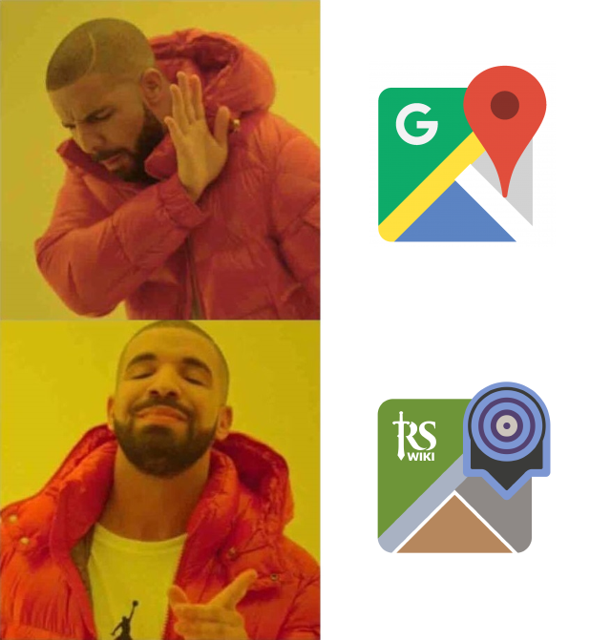
We are creating a dynamic, interactive RuneScape map that can be embedded in wiki articles. It will support zooming, panning, markup (labels, markers, paths, icons), and links between dungeon maps. This map will also be available as a standalone application.
The content of the map (not just the surface level, but all dungeons and planes) will be automatically generated from the game cache, meaning little or no effort will be required to keep it up to date.
Where possible, these will replace our existing PNG maps, whether for the entire world map, dungeon maps, NPC maps, or one-off quest maps. The new appearance should be very similar at first glance, but will be fully interactive.
Additionally, we are creating a “pathfinder” where a user can specify two locations, and we will give the shortest path (subject to the user’s constraints) that goes from one point to the other.
If this project is successful, we will extend it to Old School RuneScape, since most of the work is transferable.
It’s basically Google Maps for RuneScape. Who’s in?
See this page for a very rough prototype of the map, and of some of the pathfinder work.

Design mocks
Moved to https://sketch.cloud/s/Eq5O2

Map generation
The entire map is generated using the RuneScape game cache. RuneScape is divided up into “map squares” of 64 by 64 tiles, and for each map square, there is an archive in index 5 of the cache that contains information about the objects and tiles in that square.

Relevant cache locations
- 2.1 — Floor underlay definitions
- 2.4 — Floor overlay definitions
- 2.34 — Mapscene definitions (rocks, trees, ladders sprites)
- 2.36 — Map label definitions (minimap icons, labels)
- 5.x.0 — Land objects
- 5.x.1 — Water objects
- 5.x.3 — Land tiles
- 5.x.4 — Water tiles
- 19 — Object definitions
- 23.0 — World map zone definitions
- 23.1 — World map pastes
- 23.2 — World map PNGs (small)
- 23.4 — World map PNGs (big)
- 42 — Coordinate to label mapping (2.36)

Tiles
Files 5.x.3 and 5.x.4 contain information about the 64x64 grid of tiles in 4 planes. For each tile, we get the underlay, the overlay (and shape), height, and whether the tile is walkable.

Underlay
Each tile has an underlay that tells us which floor definition (read: which texture and color) to use as the base for the map. This is then smoothed across multiple squares to give a less jagged look for the underlay.

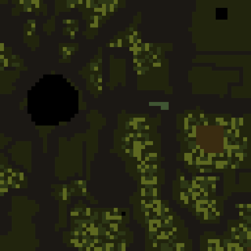 | 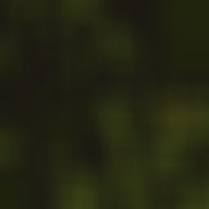
Before smoothing | After smoothing

Overlay
Most tiles also have an overlay, which might be a road or a building or something else. This gives us a color, and also a shape and rotation, to paste on top of the underlay.
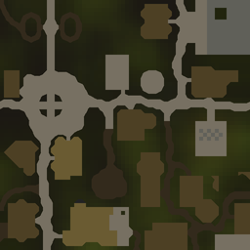
Look familiar yet?

Objects
Every object (crate, cave entrance, tree, etc) in RuneScape has an ID associated with it. Cache entries 5.x.0 and 5.x.1 give us a list of all object IDs in the square, with their locations, type, and rotation.

Walls
If the object has a particular type, it signifies that the object should be a wall on the map.
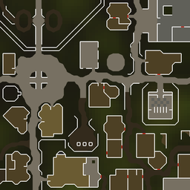
Starting to look good…

Mapscenes
Some objects (like trees) will automatically create a sprite on the world map. This is specified in the object’s definition. This even includes a fake mapscene for things they want to pretend are NPCs, like dairy cows. We choose to ignore this one.
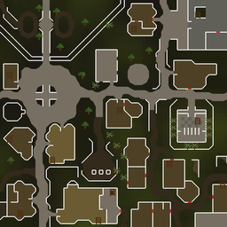
/r/trees

Minimap icons
Minimap icons are specified in two ways: either directly on ingame objects (similar to mapscenes), or, if they don’t always display (due to unlocks or quests), in the labels cache file. Either way, we can get them, although we won’t really display quest ones for the most part. Note that we won’t have the minimap icons directly in the map image -- they’ll be a separate layer.
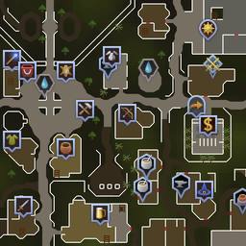
It actually looks like the map now!

Map display
The map is displayed using LeafletJS.

Implementation
<TODO: CRS, zooming, SVG exploration?>
After generating all the map squares in the above section, we can display them with LeafletJS’s tiling functionality.

Bounds and settings
<TODO: defaults?>
The map will support zoom levels between 12.5% and 200%
Similar to the ingame map, our map will support the following settings:
- Toggle minimap icons
- Toggle map labels

Additional overlays
<TODO: more overlays, details>
- Teleport map
- ???

Markup
<TODO>

Minimap icons
There are approximately 2,000 minimap icons on the RuneScape Surface map.

Labels

Drawing
It’s important that we’re able to draw lines and squares and markers on the maps, since this is a core requirement of NPC maps and dungeon maps. LeafletJS support this out-of-the-box, although we will likely define custom markers and fills to standardize.

Dungeons and links
<TODO>
There are approximately 707 different areas in RuneScape that will open up a distinct map when you try to use the world map. Some of these are obvious (RuneScape Surface, large dungeons), but some are less obvious, like random rooms from old quests.
We would like to emulate this behavior in our map.

Higher planes
<TODO>
Climbing up a ladder usually takes you to the next plane up. RuneScape has 4 planes, and while everything except the first are empty relatively speaking, there’s still a fair number of buildings that span multiple floors. We need to have a plan for how to display them.
Have something like this from Google Maps. Does LeafletJS support this in any way?

Pathfinder
There will be additional functionality in the map where a user can specify two locations, and we will give the shortest path (subject to the user’s constraints) that goes from one point to the other.
Part of this involves having a good handle on the transportation network, and part of it involves knowing which squares can be walked to from other squares.

Transportation network
This is a manual process of just doing all of the 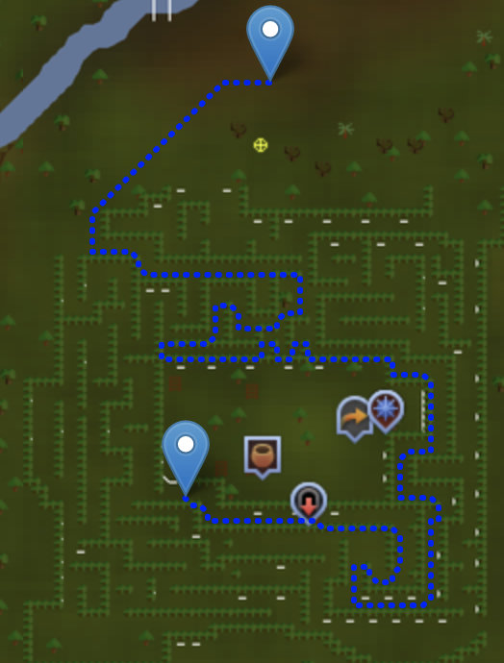teleports and seeing how long they take and where they go. There is a project underway to do this: see TODOs at the bottom of this document.

Movement data
Maze? What maze?
The game cache contains information about which map tiles can be walked on, and it also tells us about the objects in a map square. Some of these, depending on their type, restrict movement either completely (for example, trees), or only in some directions (walls). With this ensemble of information, we can say exactly what tiles can be walked to from any other tile. This is starting to sound solvable!

Problem statement
At any given tile, a player has the option to:
- Move in any of 8 directions, if available
  - Takes 1 tick if walking, or half a tick while running.
  - (Technically it’s 2 tiles per tick when running -- we’ll handle this rounding error elsewhere)
- Use some part of the transportation network that is available from anywhere
  - Example: lodestones
  - We can ignore this option unless it’s the first tick of the entire route, otherwise it’s not the most efficient
- Use some part of the transportation network specifically available from that tile, if available
  - Example: Charter ships
All of these tiles can be thought of as a directed graph, where nodes are individual tiles, edges mean there is a way to go directly from one tile to another, and edge weights correspond to how long that transportation option takes (might be half a tick for running one square, or 30 ticks for some particularly slow teleport).
With this graph and requested start and goal tiles, we can run a shortest path algorithm to find the ideal path.

Algorithm
Despite roughly 8 years of thinking about this, I haven’t been able to come up with a super slick algorithm that optimally solves this problem faster than the old classic, Dijkstra’s algorithm.
Even a basic A* implementation runs awry, because any heuristic you choose will probably not work. A* returns the optimal solution if the heuristic you give it is admissible.
For those of you that didn’t get shoved in lockers as children, this means that this algorithm runs correctly if you can figure out a semi-decent way to estimate the minimum travel time between two places, without ever underestimating the time.
If all we could do is walk, then finding an admissible heuristic would be easy: certainly if you’re, say, 1000 squares north and 500 squares east of where you want to be, it will take at least 1000 steps to get there, which is at least 300 seconds.
But with the existence of teleports, this all runs aground. Even though you’re very far from your goal, it could be the case that there’s a boat nearby (or a wormhole, or a cave goblin) that just takes you directly where you need to go instantly. Most shortest-path algorithms are notequipped to deal with this.
There are about 327,680,000 possible map squares in RuneScape, although my estimate is that only about 2,000,000 of them are actually walkable. Meanwhile, there are around 400-500 distinct things in the transportation network. If all we had to do is find the shortest path within that transportation network, it’s easy because the graph is small. Conversely, if all we had to do is find the shortest path by only walking (no transportation network), that’s also easy because there are really efficient algorithms for optimal pathfinding in uniform grids (A* and jump point search all perform well with minimal node expansion).
I have some ideas for how we might still maintain optimality without expanding all the nodes a la Dijkstra, so long as we pre-processed effectively. However, to my surprise, Dijkstra performed well enough in the prototype to make me think it will be an acceptable algorithm here.
If you’re a graph algorithm wizard, please reach out to me (Cook Me Plox) if you want to discuss how to solve this problem.

Implementation
<TODO: detail about data structures/provide code>
I implemented pathfinding using Dijkstra’s algorithm on the map movement and teleportation data. It’s written in Java, and is a fairly standard Dijkstra implementation, except we’re taking advantage of the fact that all the path weights are discrete rather than real (and usually increasing by 1 each time), so we can just use an alternating series of 2 arrays as our fringe, rather than using a priority queue, which comes with an extra log(n) runtime factor.
To my surprise, this is highly efficient -- expanding 500,000 nodes takes less than 0.04 seconds even on my budget DigitalOcean machine, and most paths are found in about 0.02 seconds or less. I was aiming for 0.1 to 0.2 seconds, so this is great (although performance will decrease as more areas become accessible to searching, besides just the main world).
This pathfinder is connected to an HTTP server application that is running on the wiki’s toolserver. It’s a very basic endpoint right now that takes in a start and end tile and returns the shortest path.
Right now the front-end calls that endpoint in response to user click events, drawing the resulting path on the map using LeafletJS.

Teleport configuration
<TODO>
Users will be able to determine which teleports and shortcuts they want to allow, either due to requirements, or just general difficulty in using/obtaining the teleport. This will be sent, along with the start and end coordinates, to trim down the transportation network used in the algorithm.

Results display
<TODO>

Wiki Integration

Map replacement
<TODO>

Links
<TODO>

TODOs
If you want to help with any of this, drop a line in #cartographers on the wiki Discord.

Map generation
All assigned to Cook unless otherwise specified. (Ralph for OSRS)
- Display bridges, docks, etc on top of water correctly (plane 1) (I think I have same problem with OSRS I think, have black edges)
- Clean up stray walls that don’t belong (can you give an example so I can check this?)
- Clean up walls in water/around big objects, that don't belong
- Figure out what makes a door red (might help, code from RuneLite: https://imgur.com/a/HeRbgoR )
- Fix overlay for Grand Exchange, Lumbridge Mill, others
- Display Prifddinas correctly
- Display surroundings of dungeons correctly (too much showing now)
- Don’t skip map icons out of range

Map display
- Create additional layers for minimap icons (separated into categories?) and map labels
- Determine the best way to show icons conditionally rather than loading all of them onto the map at once because of the performance impact
- Create layers for fairy rings and other teleports? (can pull from pathfinder work)
- Display areas separately - the whole rendered map should not all be visible at once, only the world map initially

Pathfinder
All assigned to Cook unless otherwise specified.

Backend
- Make pathfinding script robust to SSH disconnects (nohup?)
- Standardize input and output format
  - JSON to/from/settings
  - JSON path parts (labels server-side)
    - Fix edge case where 2-part teleport destination is final point
    - Refactor to remove duplicate code
  - Standardize movement ids
- Standardize teleport data format
  - Need id, start, end, time, [title, description/requirements, image]
- Get bridges and water objects working
- Get full set of object data for surface map (Wilderness problem)
If no exact match, back off to close match (destination side)
- Round running up at every teleport, door, interaction
- Think about how to generally support doors/walls
  - Or identify ones worth looking at (right click options?)
- Support empty start (require first teleport)
- Support multiple paths/configs per request
  - Or show this isn’t necessary
- Find between multiple areas in space-efficient manner
  - Need to do some cache digging on 23 to get area bounds
  - Array of arrays? Should still be majority-surface
    - Map from 64x64 map square to “area” id
  - Need to grab obstacles/nomove in accordance with this
- Restrict teleport options based on user configuration
- Wilderness restrictions
- Be smarter about FRINGE_SIZE
  - Or just use ArrayList (benchmark first)
    - ArrayList<Integer> makes entire program 50-100% slower :(
- Benchmark/stress test pathfinder server
  - Monitor memory usage
- Automate reloading
- Support multiple destinations, either in order or any order (TSP)
  - Use Held-Karp for TSP
- Support Surge
  - Is this even possible?

Frontend
- UI for direction finding (see mocks)
  - Iiii I I I, Gaz, Jayden
- UI for teleport customization
  - Iiii I I I, Gaz, Jayden
  - Figure out how to specify the UI from a JSON file or something easily updated
- Exclude teleport method
  - Iiii I I I, Gaz, Jayden
- Develop path lines and route description display
  - Iiii I I I

Data gathering/non-technical
- List all teleports and transportation methods with their exact locations and time taken
  - Cuxrie, ThePsionic, Jayden, Kelsey
- Give titles, icons and short descriptions/requirements (see pathfinder mockup) for all transportation methods
- Catalog doors and gates and ladders

